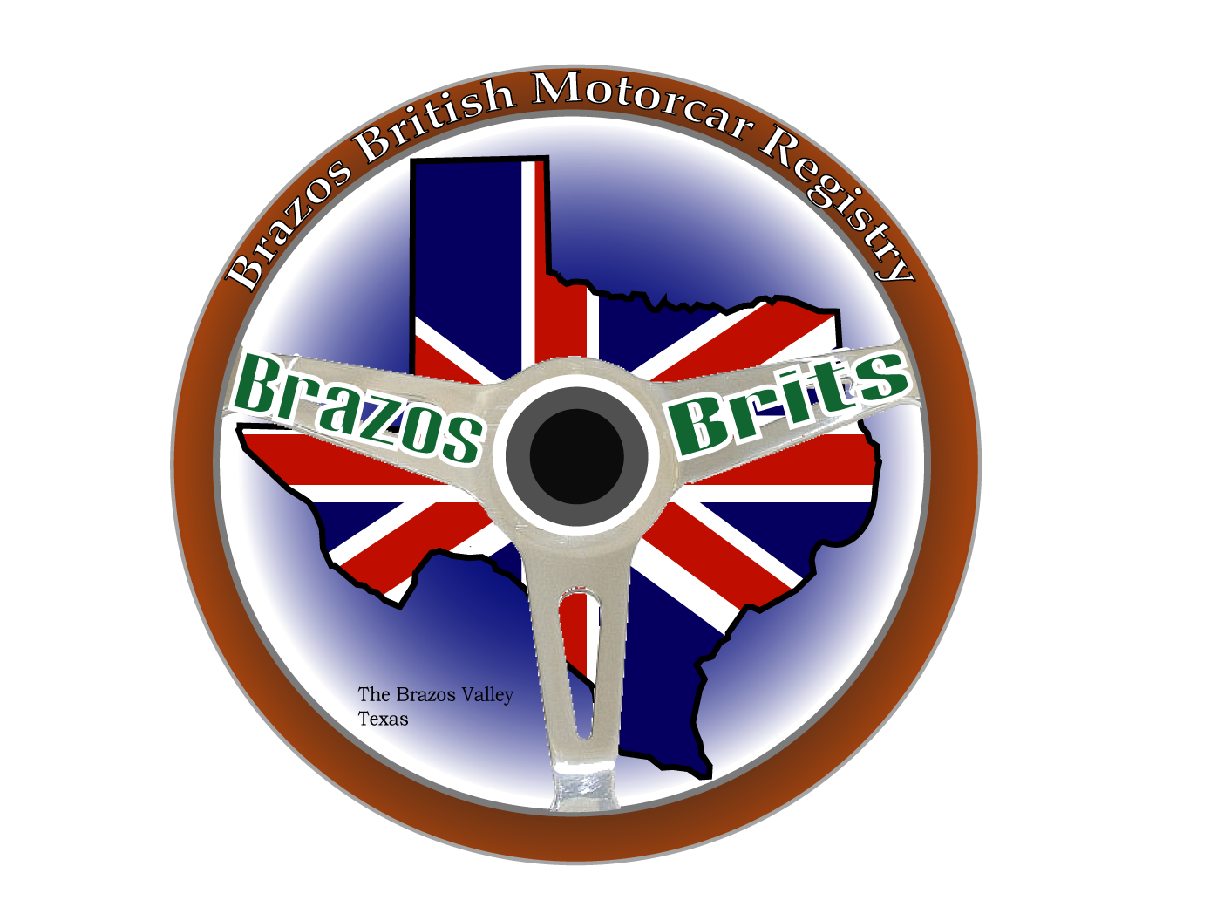

1964 Morris Mini

1100cc Inline 4-Cylinder ~60 HP modified

Top Speed – 90mph

Fuel economy – 35mpg with a tail wind

Weight – 1450 lbs.

Wheels – 10 inch

Over 6 million built in England between 1959-2001 by Morris, Austin, BMC, British Leyland and the Rover Group.

